

**Faculty of engineering - Shoubra**

**Benha University**

**Research Article / Research Project / Literature Review**

in fulfillment of the requirements of

|  |  |
| --- | --- |
| **Department** | **Engineering Mathematics and Physics** |
| **Division** | **--------------** |
| **Academic Year** | **2019-2020 Preparatory** |
| **Course name** | **Computer** |
| **Course code** | **ECE001** |

**Title: -**

**Artificial Intelligence**

By:

|  |  |  |  |
| --- | --- | --- | --- |
|  | Name | Edu mail | B.N |
| 1 | **عمر وليد عمر حافظ** | **Omar195633@feng.bu.edu.eg** | **573** |

**Approved by:**

|  |  |
| --- | --- |
| Examiners committee | Signature |
| Dr. Ahmed Bayoumi |  |
| Dr. Shady Elmashad |  |
| Dr. Abdelhamid Attaby |  |

**Github link:** [**https://omarwalled.github.io/ECE001/**](https://omarwalled.github.io/ECE001/)

**Research objectives**

I aim in this research to discuss all about the artificial intelligence and its methods, goals and benefits.

That the intelligence exists all about us almost in any technology surrounding us.

We mustn’t forget that this technology and artificial intelligence is made by humans

**-------------------------------------------------------------------------**

**Abstract**

Everything we love about civilization is a product of intelligence, so amplifying our human intelligence with artificial intelligence has the potential of helping civilization flourish like never before – as long as we manage to keep the technology beneficial.

This research consists of 4 pages in addition to the main page that I will discuss all about the artificial intelligence and its applications.

Artificial intelligence is in almost all the technology surrounding us that nearly we can’t replace it or leave it.

**Table of contents**

Divide your research into sections or subjects, mention each section first page at this table

|  |  |
| --- | --- |
| **Subject / section** | **Page** |
| Main page | Screenshot 1,2 |
| What intelligence is | Screenshot 3,4 |
| Methods and goals in AI | Screenshot 5,6 |
| Alan Turing and the beginning of AI | Screenshot 7,8 |
| Early milestones in AI | Screenshot 9,10 |
| Strengthen AI possibility | Screenshot 11,12 |
| Results and discussions | 10 |
| Conclusions | 11 |
| References | 11 |

**-------------------------------------------------------------------------List of Figures (If any)**

|  |  |  |
| --- | --- | --- |
| **Figure I.D** | **Description** | **Page** |
| 1 | Artificial intelligence imagery | Screenshot 1 |
| 2 | Artificial brain | Screenshot 3 |
| 3 | A small robot | Screenshot 5 |
| 4 | Alan Turing | Screenshot 7 |
| 5 | Humans against robots | Screenshot 8 |
| 6 | Early milestones in AI | Screenshot 9 |
| 7 | A robot thinking | Screenshot 11 |

**-------------------------------------------------------------------------**

**Source code**

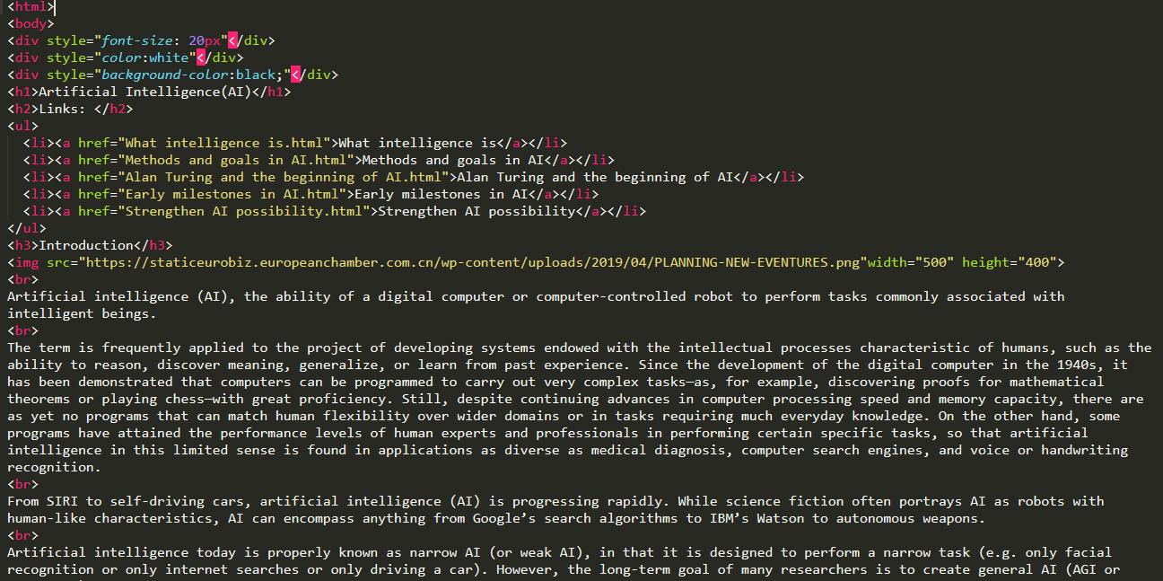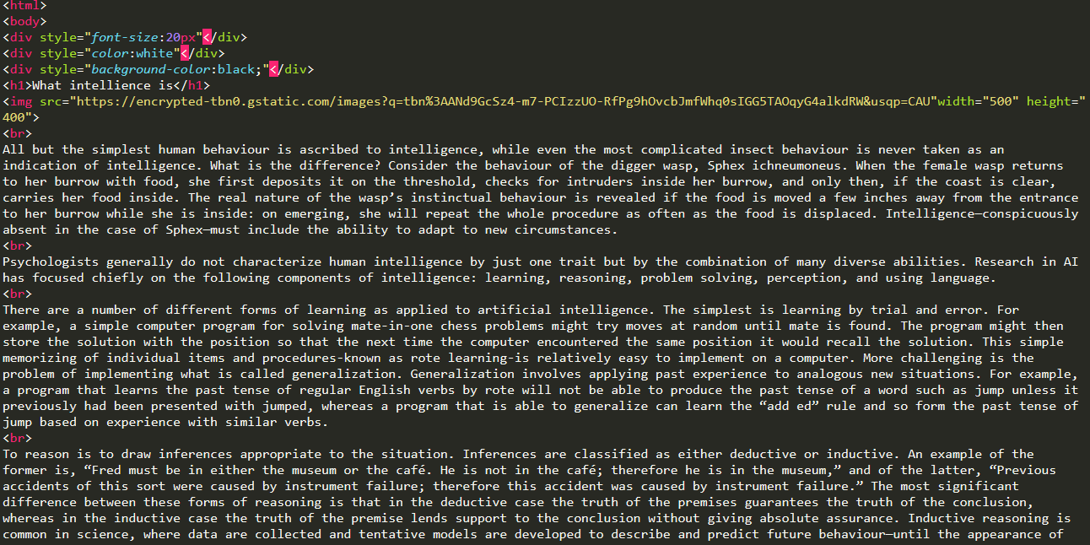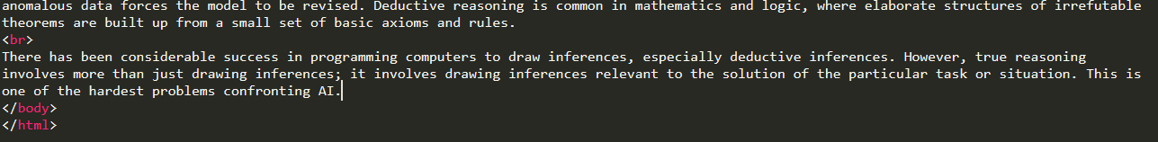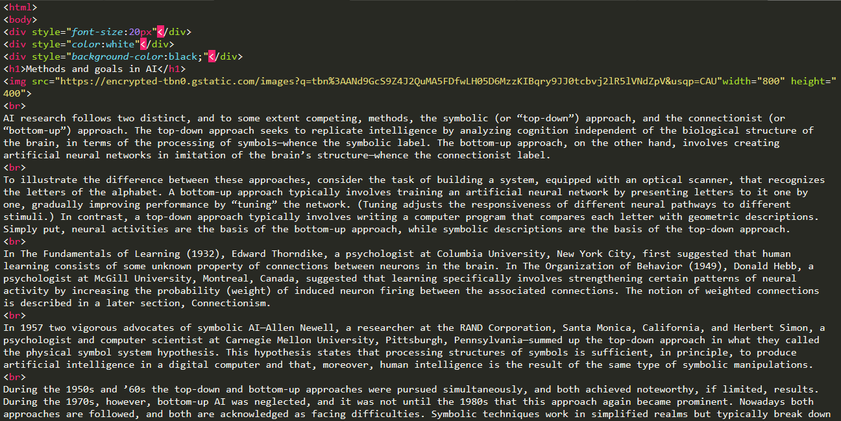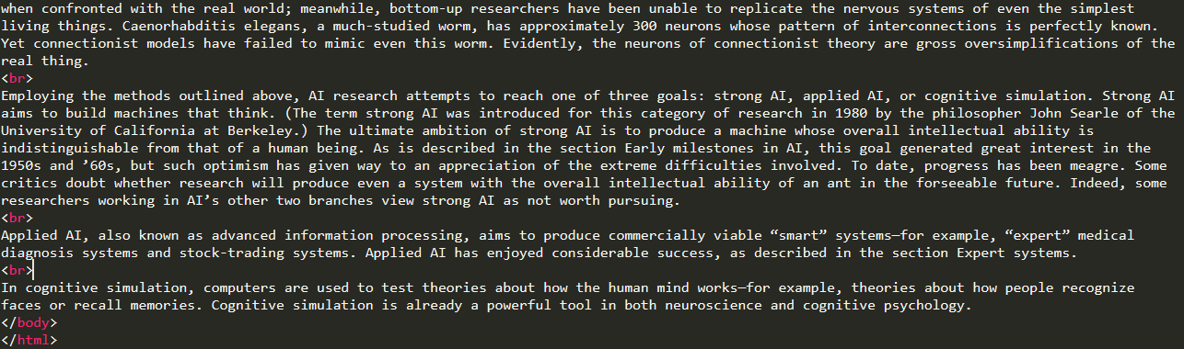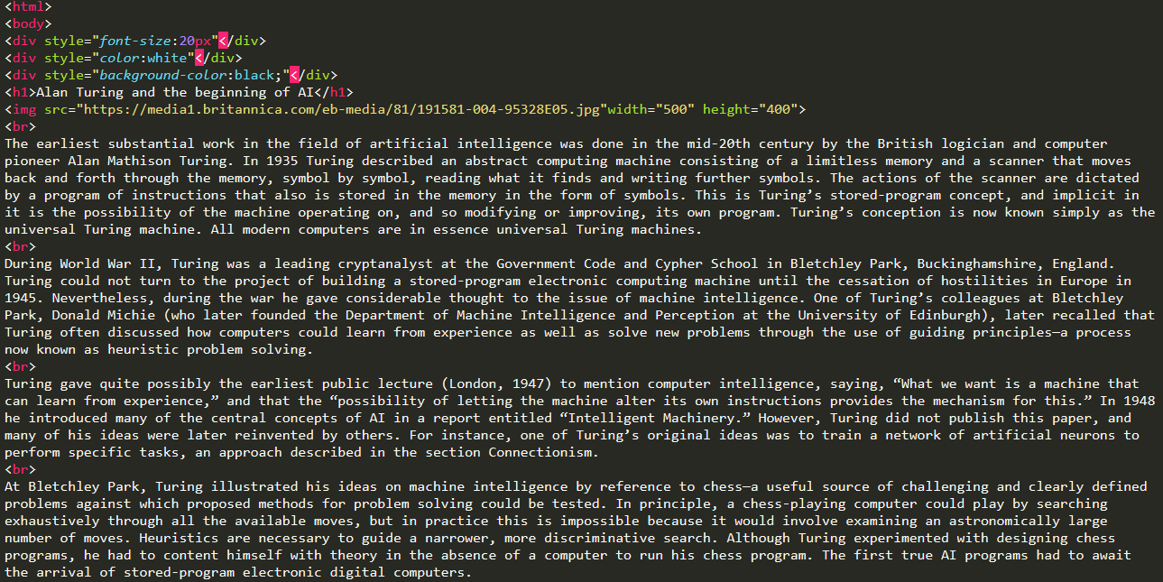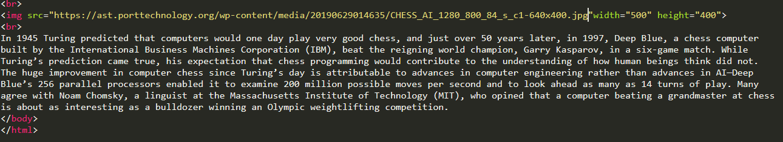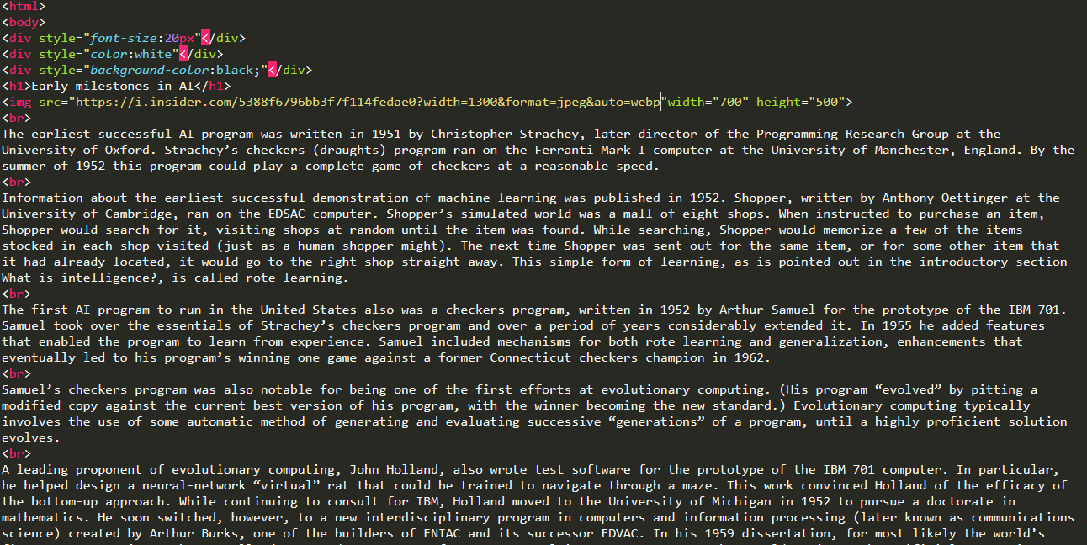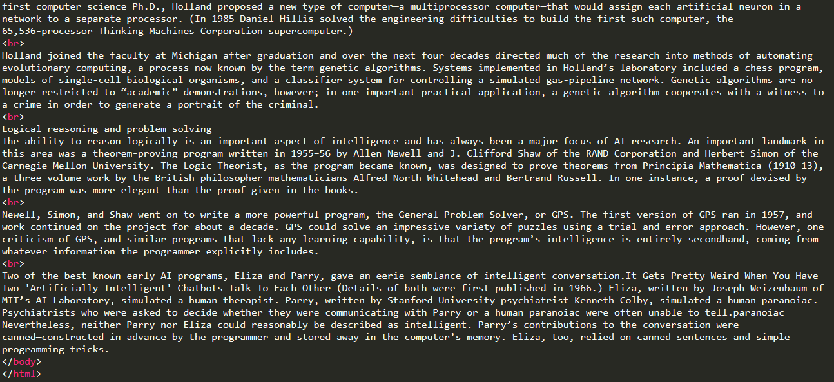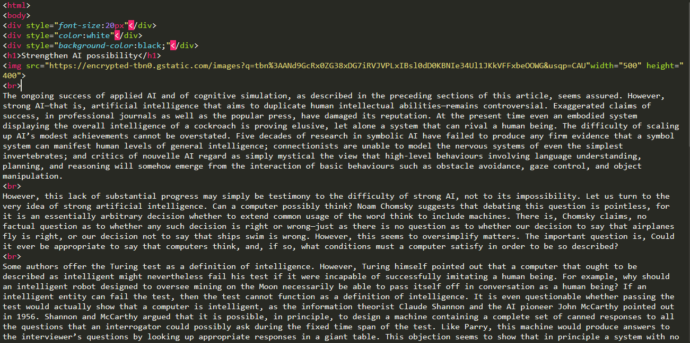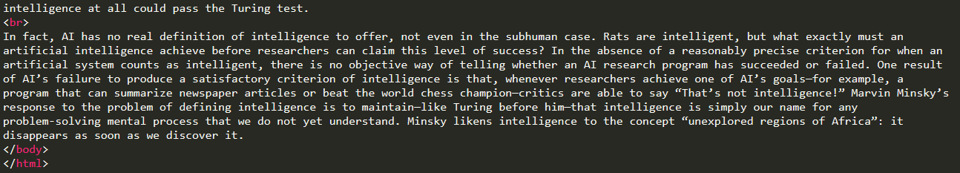

**-------------------------------------------------------------------------**

**Screenshots**

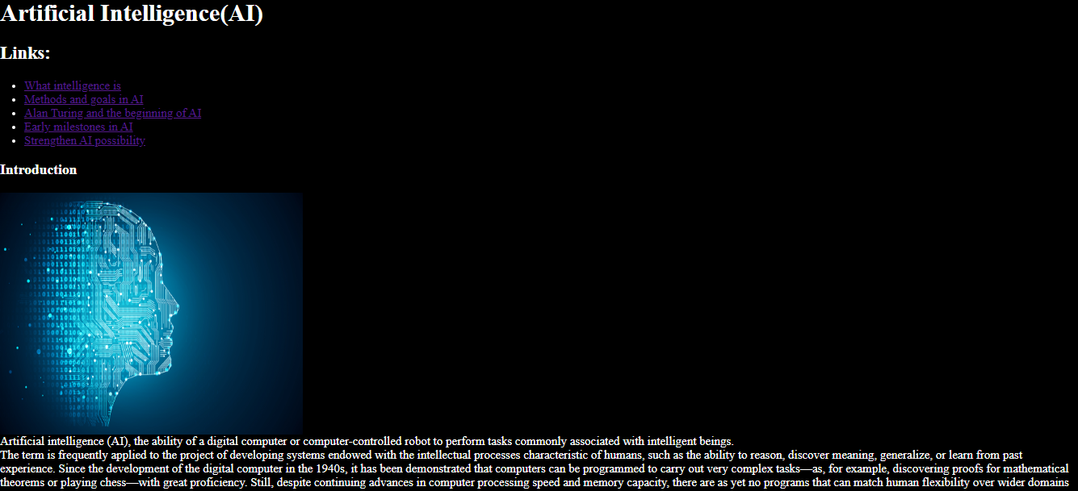

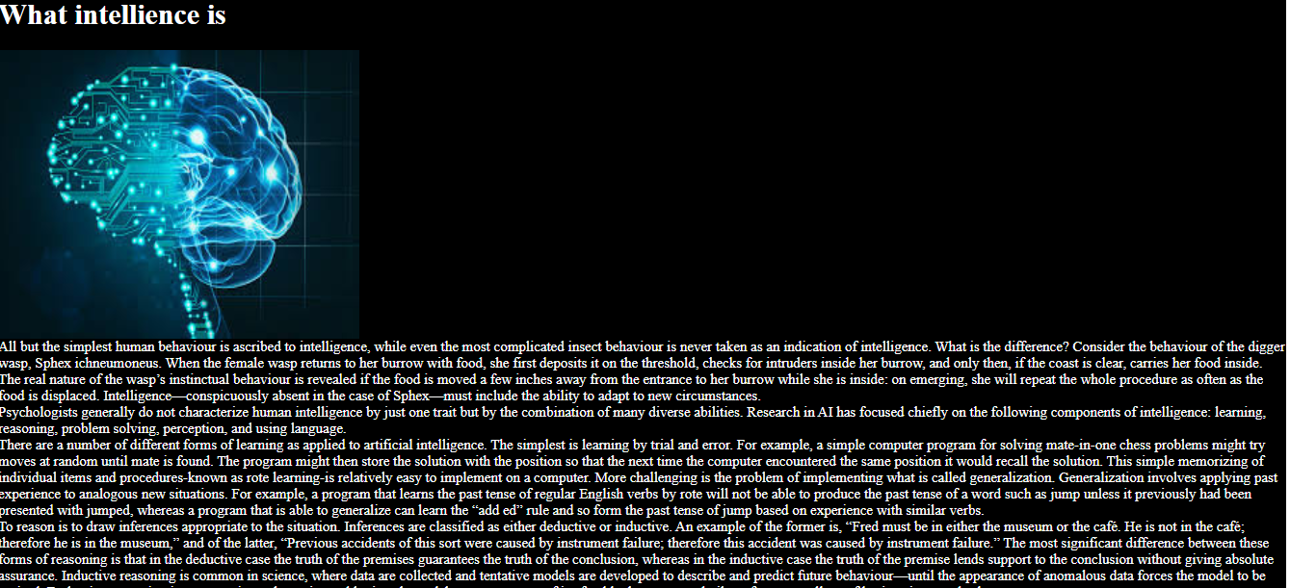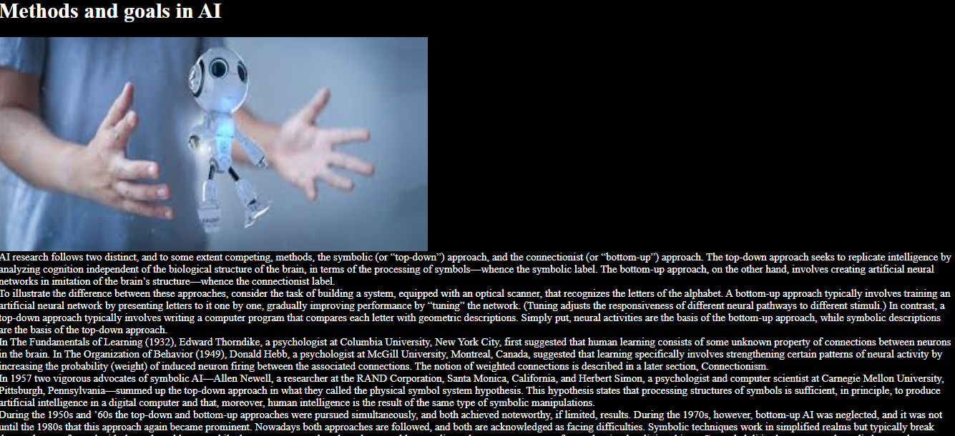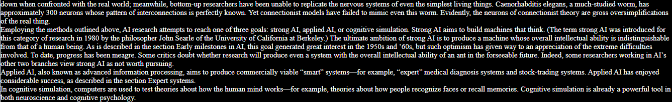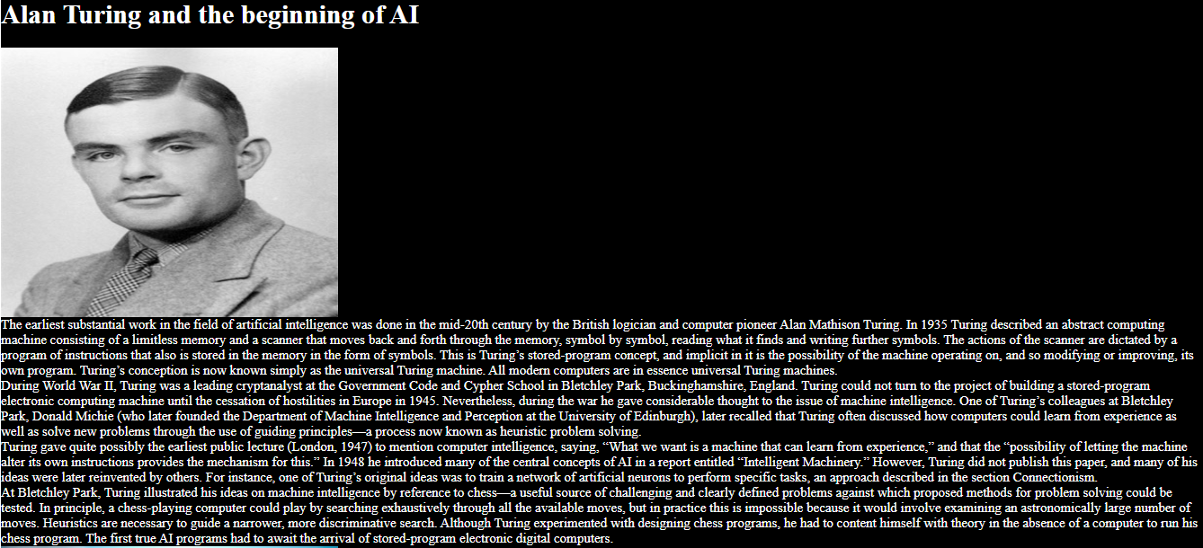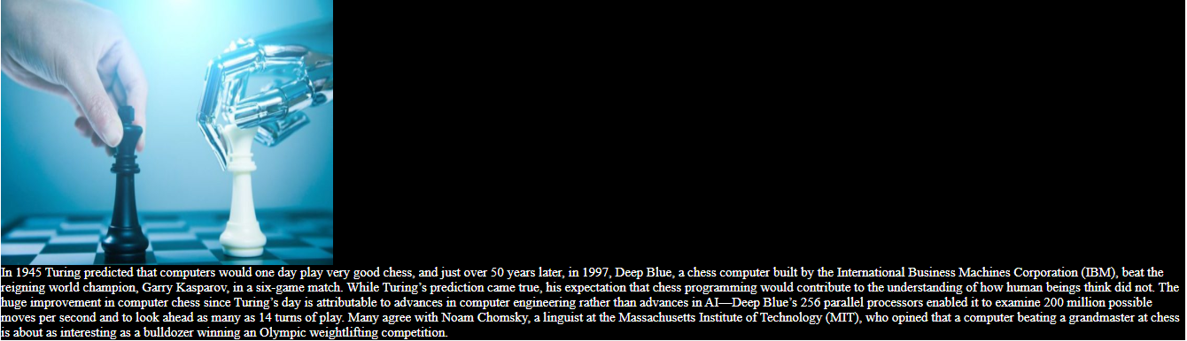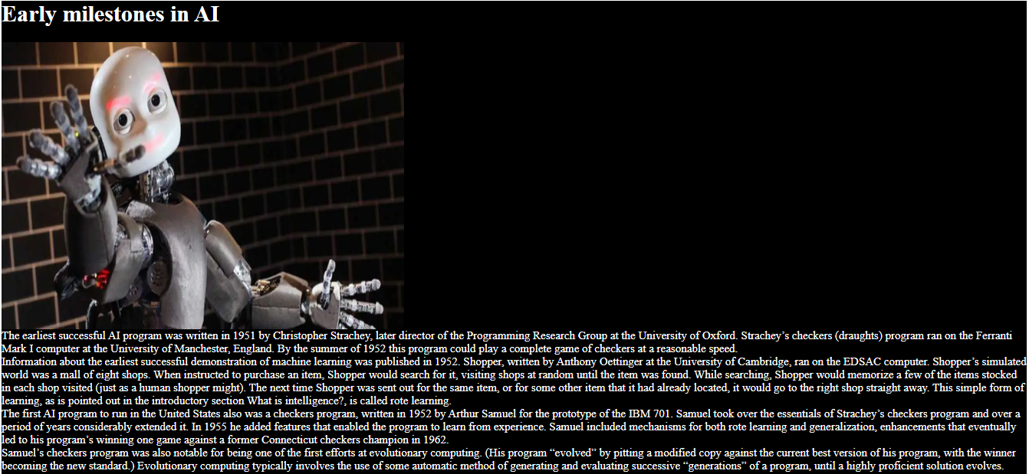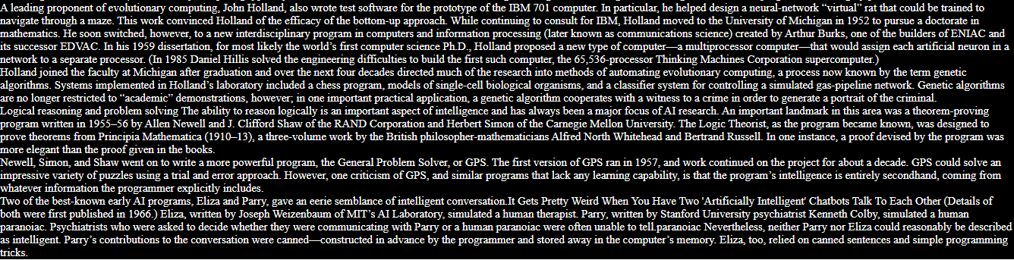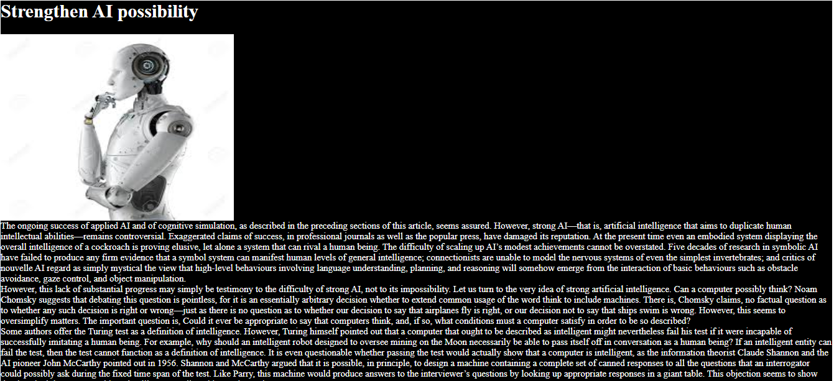

**-------------------------------------------------------------------------Results and discussion**

This research resulted in we knew more and more about the artificial intelligence and its applications that we use every day and nearly every hour in our day and almost we can’t live without it.

And we should take care of that intelligence and develop it to achieve more success in this branch and to help people in their lives.

Artificial intelligence exists in computers, robots, televisions and so on in different types of technology.

**-------------------------------------------------------------------------**

**Conclusions**

Artificial intelligence is very important in our life that we can’t leave it and we should keep use it all the time to achieve more and more success in the technology science.

Technology and artificial intelligence often exist in the computers and another types of technology equipment.

The artificial intelligence is in the robots as they can think and do tasks as simple as humans.

But we can’t replace the humans with the robots as without humans the robots won’t exist and what ever is done the robots can’t think as humans think.

**-------------------------------------------------------------------------**

**References**

1. Egyptian Knowledge Bank, EKB.
2. Britannica academic.
3. Benefits & Risks of artificial intelligence.